This graph shows **violin plots** comparing the **pulse** rates of individuals across different types of activities ("rest," "walking," and "running") over time ("1 min," "15 min," and "30 min"). The comparison is further divided into two dietary groups: **no fat** and **low fat** diets.

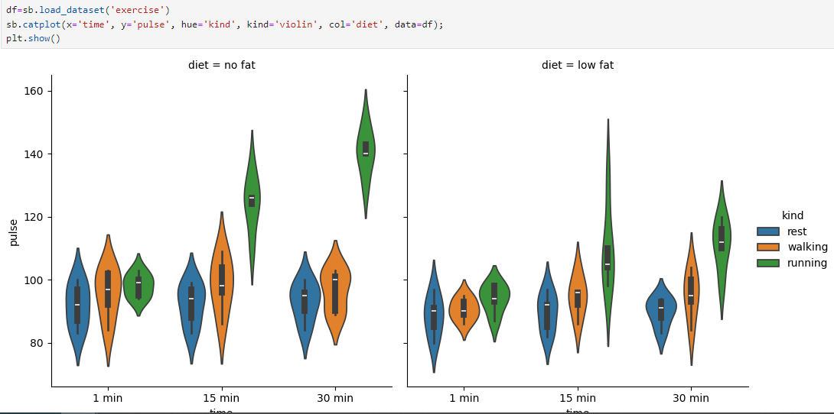

**Key Observations:**

1. **Diet Comparison**:
   * The left panel represents people on a **no-fat diet**.
   * The right panel represents people on a **low-fat diet**
2. **Pulse Variation Across Activities**:
   * **Rest** (blue) shows consistently lower pulse rates across all time intervals (1 min, 15 min, 30 min).
   * **Walking** (orange) has moderate pulse rates that increase slightly over time.
   * **Running** (green) has significantly higher pulse rates, especially at **30 min (no fat), at 15 min (low fat)**, which is visibly higher in both diet categories.
3. **Effect of Time**:
   * In both diet groups, pulse rates tend to increase as time increases from **1 min** to **30 min**, particularly for the "running" category.
4. **Differences Between Diets**:
   * There is no significant difference in pulse for the "rest" and "walking" categories between the two diets, as their shapes and ranges overlap.
   * For "running," the **low-fat diet** group shows a slightly wider range of pulse rates, especially at **30 min**, where it has a higher peak pulse rate than the no-fat group.
5. **Shape of Violin Plots**:
   * The **wider** portions of the violin plot represent higher density, meaning more people have pulse rates around those values. For instance, under **running**, the pulse rates are 120+ in both diets.